**ROYAL FINANCE**

**Introduction:** Overview of the financial analysis.

**Royal Financial:**

Royal finance is a software finance company. It is the crucial process for evaluating the performance and health, company, investment or finance portfolio. It involve the assessment of data and metric make informed decisions and gain insight into financial standing of and entity. This is a vital for both investors and business, as it help in making informed decision, managing risks, and optimizing strategies.

Common examples of financial metrics include revenue, net income, earnings per share (EPS), return on investment (ROI), return on equity (ROE), price-to-earnings (P/E) ratio, and debt-to-equity ratio. By analyzing these metrics, stakeholders can gain insights into a company's profitability, efficiency, liquidity, solvency, and overall financial performance.

**What are the top 3 key financial metrics in Royal Finance company?**

There are 3 top financial metrics that are important in every company: revenue, net profit, and burn rate.

Revenue is the income generated through your business’ primary operations, often referred to as the “top line.” Net profit is the dollar value that remains after all expenses are subtracted from your company’s total income, often referred to as the “bottom line.” Net burn, or burn rate, is the amount of money a company loses per month as they burn through cash reserve

**Royal Finance Company investment return in year 2023:**

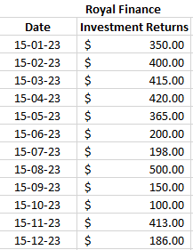

**Chart: Line chart showing historical performance of the investments.**

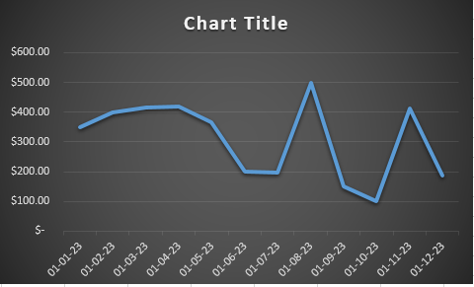

**Summary of average return AND standard deviation:**

The annualized return formula calculates your ROI as the average gain or loss you've made in a year 2023 on your initial investment. This is displayed as a percentage, and the calculation.

